**Name: Arid No. :**

**Class: BSCS Section:**

**Assignment No. : 1 Date: 27-10-2022**

**Question:**

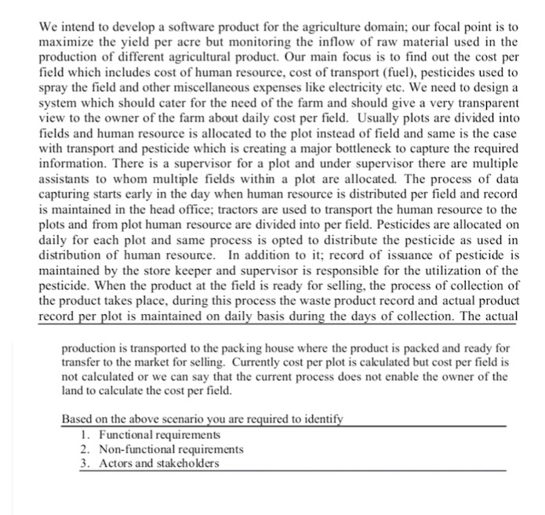

**Answer:**